1. Theory of operation

2. Procedures

2.1 Windows

2.2 OS X

3. Connecting to Ares

3.1 What next and what if

Ares 3D 4-in-1 (printer, scanner, laser engraver and CNC engraver) uses a Raspberry Pi as front end to simplify software requirement. The Pi speaks TCP/IP so all you need is a Web browser and some STL 3D model. Whereas this offers great convenience, some users, especially those who are used to direct interaction with Arduino’s USB port, find the arrangement confusing. It does not help that Ares’ instructions are poorly written. Even I myself found them so difficult to follow that I muscled through installation using my own networking knowledge instead. (Hence my very first Ares tip, [Use router to simplify network connection](http://www.easyarts3d.com/forum/viewtopic.php?f=22&t=453). But direct cabling could be easier for others.)

This document will show you how to connect to Ares using the provided Ethernet cable, not necessarily for your future use but enough for you to go configure your Wi-Fi. This procedure applies to any OctoPi based printer. (As well as to any headless Raspbian and other Pi operating systems that enable DHCP on Ethernet by default. AstroBox is a known exception as it is not meant for headless installation.) Instructions are for Windows and MAC. The theory applies to Linux systems, too.

## 1. Theory of operation

The idea is to set up a point-to-point network between your computer and the Pi in Ares without any networking equipment and much knowledge about networking. You need an Ethernet cable and a DHCP server.

I didn’t realise until after I received my Ares that modern day hardware and software have enabled a layman to do just this. Gone are the days when some network guru will tell you to go make a crossover cable on the workbench, then either learn some obscure numbering scheme or install some obscure server in order to do this. Most Ethernet ports today are auto sensing. So the Ethernet cable shipped with your Ares can be used with a network switch as well as in a point-to-point configuration. The “Internet sharing” feature in your computer’s operating system provides a DHCP server. So all we need to do is to plug the cable and enable “Internet sharing” even though that is not our purpose.

Still, if you have access to your network’s Ethernet switch, you can connect your printer to that and save some trouble. (See [Use router to simplify network connection](http://www.easyarts3d.com/forum/viewtopic.php?f=22&t=453).)

Ready to go? Keep in mind that OctoPi is the operating system on Raspberry Pi in your Ares. Out of the box, it seeks to find DHCP service on Ethernet. Many modern operating system are configured this way out of the box.

## 2. Procedures

First thing first: Insert one end of the Ethernet cable (RJ-45) into your computer, the other end into Ares’ external USB port.

### 2.1 Windows

First, you need to get into the “Properties” window of a Wi-Fi card in “Control Panel -> Network and Internet -> Network Connections”.[1] There are many ways to get there. In the following screenshot from Windows 10, you click on the card then click “Organize”. One of menu entries near the bottom is “Properties”.

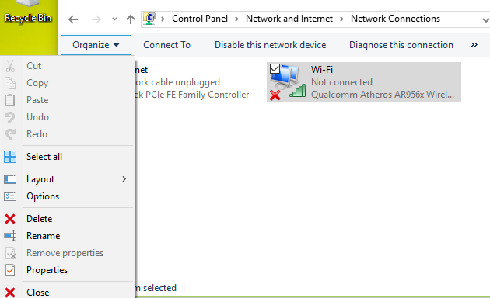*-

In the following screenshot, you right click on the card. “Properties” will be the last entry.

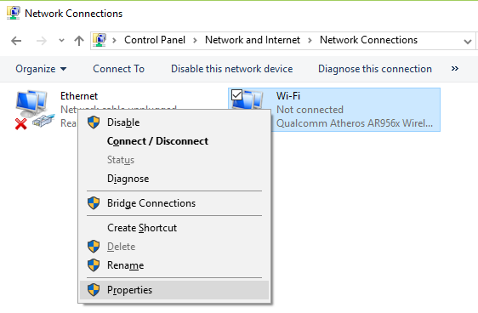

Most likely, your active Wi-Fi card is displayed as a network icon in Windows’ taskbar. You can right click there, too.

Once in Properties window, select “Sharing” tab which is to the right of the default tab, then check “Allow other users to connect through …” then click “OK”. That’s it.

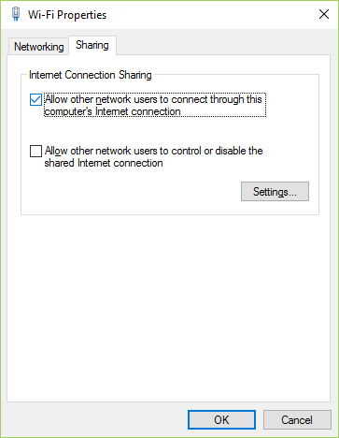

### 2.2 OS X

In OS X 10.9 (Maverick) and above, the place to enable Internet sharing is moved to its own applet called, surprise, “Sharing”. Find it in “System Preferences” application. (It has a square icon with a gear in the middle.)

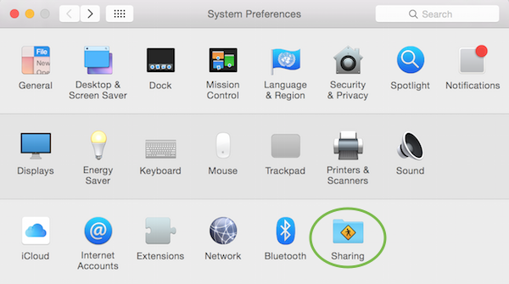

If you have never set this up, you should see a screen like the following:

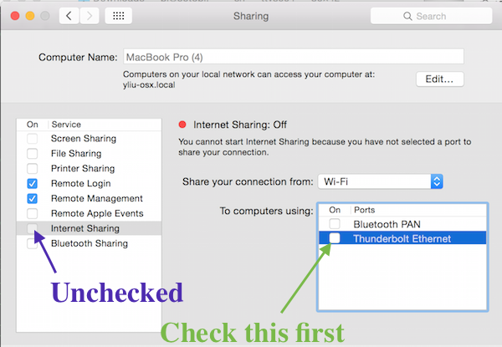

Next, check the Ethernet port under “To computers using:”, then check “Internet Sharing”, in that order. (Note your port name may be different.) If for some reason your computer already checked “Internet Sharing” but the Ethernet port is not selected, you must uncheck “Internet Sharing” first before you can change port selection.

Upon checking “Internet Sharing” for the first time, a dialogue box will pop up asking “Are you sure... ?” Confirm by clicking “Start”.

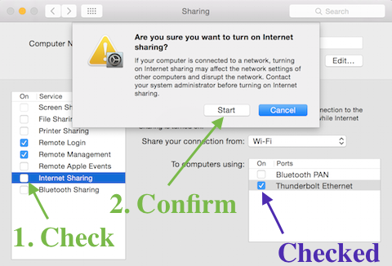

Now, if you have never shared Internet on your computer, you’ll need to go back to “System Preferences” and open “Network”. Another dialogue will pop up:

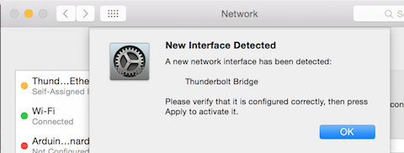

Just click “OK” in the box and then “Apply” in “Network” applet.

## 3. Connecting to Ares

Quick: Have you turned on your Ares? This is your last chance or your beautiful machine will escape into Ether. Kidding. If your Ares is turned on, you should be able to connect to Ares using any Web browser by pointing to <http://octopi.local/>. Yes, you can directly click on the link because by reading my guide thus far, your network has been owned. Kidding again - but the link doth work.[2]

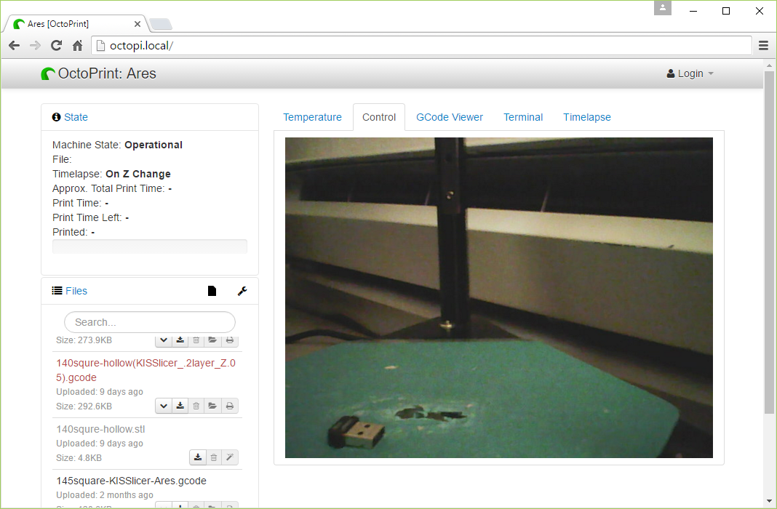

Note the Wi-Fi dongle on the print bed? I want to show you that the printer is indeed connected via Ethernet, not Wi-Fi.

Now you can drag and drop your G-code and start printing; you can even drag and drop STL file and start printing. ([Print your STL model with one click/drag-and-drop](http://www.easyarts3d.com/forum/viewtopic.php?f=22&t=1624))

### 3.1 What next and what if

You can use your Ares in this manner, tethered to your computer. But it would be more fun if you can run your printer untethered. Like, via Wi-Fi. On your phone. For this, and for some other tasks, you’ll have to read further into the manual. (Mac users can also look at [Ares (OctoPi) Notes for Mac Users](https://drive.google.com/open?id=1IT8oxcclGMtbmQySTYrmalaBomy76IhuK8KieIDsQfk).)

What if my browser cannot open the link? Bonjour is convenient but not foolproof. That is why User Manual shows how to discover Ares’ IP address. A MAC example would be:[3]

$ arp -i bridge0 -a

? (192.168.2.1) at de:ad:be:ef:96:64 on bridge0 ifscope permanent [bridge]1

? (192.168.2.2) at de:ad:be:ef:6d:cd on bridge0 ifscope [bridge]

Here, there are two addresses[4] on bridge0 (the first bridge that you just activated), 192.168.2.1 and 192.168.2.2, but Bonjour fails so both names are displayed as “?”. Which one is Ares?

$ ifconfig bridge0

bridge0: flags=8863<UP,BROADCAST,SMART,RUNNING,SIMPLEX,MULTICAST> mtu 1500

options=3<RXCSUM,TXCSUM>

ether de:ad:be:ef:96:64

inet 192.168.2.1 netmask 0xffffff00 broadcast 192.168.2.255

...

media: autoselect

status: active

This tells us that 192.168.2.1 is your computer, so 192.168.2.2 must be Ares. As such, just type this address into your browser address bar followed by a “/” at the end.

If you still have problem and need assistance, remember to include output from these two commands, as people will ask for them.

1. If your computer has multiple cards, it does not matter which one you choose.
2. This, thanks to another modern day voodoo that I did not explain in Theory of Operation. Most modern-day operating systems run Apple’s Bonjour protocol so even though I do not know specifics of your network, I can predict the name that you can use to run your Ares, Windows, Linux or MAC, iOS.
3. On Windows, the same task is much messier. You can find examples in the manual.
4. Because the connection is point-to-point, there can be only two IP addresses to look at.